# Briefing Sheet

|  |  |
| --- | --- |
| **To:** | **City of Ottawa Community and Social Services Committee** |
| **From:** | **Sandy Hill Community Health Centre (SHCHC), Oasis Program Director, Wendy Stewart, Email:** **wstewart@sandyhillchc.on.ca****; 613-712-0301**  **Calla Barnette, Vice President, Action Sandy Hill (ASH) Community Association and chair of ASH’s Community and Social Services (CSS) Committee,** **callabarnettash@gmail.com****; 613-2934457** |
| **Date:** | **June 27, 2023** |
| **Subject:** | **Update on recent community engagement activities in Sandy Hill Community related to homelessness and toxic drug supply** |

In response to growing unrest in Ottawa’s Sandy Hill Community related to activities associated with homelessness and the toxic drug supply, the SHCHC and City of Ottawa hosted community consultations on:Feb 28th, March 21 and April 25th, 2023. These were open to housed and unhoused occupants – including people who use drugs, business owners, city staff, police, local social service providers, SHCHC staff and local politicians, for the purpose of creating a dialogue to capture people’s concerns and identify possible solutions. The following are recent activities that have come to fruition following these sessions to help drive community led solutions moving forward and identify all parties involved in possible collaborations to address these concerns collectively:

1. **Open Letter to the Community from Sandy Hill Community Health Centre re: our part in the current community activities:**

“June 1, 2023

To our neighbours across the Sandy Hill community

Our team at the Sandy Hill Community Health Centre (SHCHC) would like to thank you for your frank open feedback about very real concerns about your experience as a neighbour – housed and unhoused, residents and business owners in the area. We are also grateful for your efforts in helping bring forward potential solutions to help address our shared concerns in collaborative and inclusive manners. These difficult conversations are the start of where change can occur.

Between February and April, community members from across Sandy Hill participated in a series of facilitated community conversations that helped us hear your concerns and ideas about how to keep our streets safe, our sidewalks clean, and our people healthy. We also heard that we need to do better - as a health service agency and as a community partner.

As a result of these candid conversations, we would like to outline the following commitments to the community.

In the short-term, we are collaborating with members of Action Sandy Hill (ASH) Community Association and the City of Ottawa to convene a working group made up of stakeholders who can contribute ideas,

resources, and help expand our collaborative network with a solutions-driven approach. We are confident this working group can help shape how the local gaps and needs can be addressed and spearhead the work towards all other objectives that may follow.

Through this group, we will monitor the success of our collective efforts, as well as any potential gaps that remain. Our hope is that the working group will leverage data, partnerships, and innovative thinking to help put in place solutions to address these gaps.

SHCHC has identified and implemented measures within current operations to immediately expand respite services in Sandy Hill for those who are displaced. SHCHC drop-in services are now open Mondays to Fridays, 1 PM – 6 PM, at the Centre, to cover the period of highest demand. This timing has been coordinated to compliment other drop-in services who offer respite spaces in the morning.

SHCHC has been able to reallocate resources and we are in the process of expanding outreach services in the surrounding areas to the Centre. That means that this daily service, operating between 8 AM and 6 PM, will be implemented shortly to include engagement of all community members in the area, respond to localized concerns in relation to those directly or indirectly impacted by harm reduction practices, overdose response and community clean up.

We continue to ramp up to pre-pandemic service hours for the Consumption and Treatment Services. In June, this service will be made available on Saturdays and Sundays, from 8 AM to 6 PM. We are confident that this will encourage people to access services within our space as an alternative to street use. We will monitor the impact for service users and neighbours before moving to our eventual model to operate the service as designed, 7-days-a-week from 8 AM to 8 PM (anticipated by September 11th, 2023)

SHCHC is committed to supporting the working group through full engagement and practical resource supports the group desires (including meeting space / virtual meeting platform, clerical support, partner, and funder relationships, etc.).

We will continue to play a leadership role in bringing the service provider community, funders and elected officials together to address operational gaps.

In the medium to long-term, we will work hand-in-hand with the working group, partners and funders to continue to adapt our services to the changing landscape and needs. We will continue to advocate for adequate funding to meet health and social needs, including affordable housing, equitable access to health and social services, and harm reduction. We will monitor new funding, as well as opportunities to address current and emerging issues. We will continue to work with service providers and community partners to plan for safer inhalation services in Ottawa.

We commit to keeping the conversation going, to listen deeply to stakeholders, to expand and create new ways to keep our community safe and healthy for everyone, by finding solutions to our collective concerns. We are all connected by this shared experience and are deeply appreciative of this community’s drive to create a responsive, vibrant, and connected community for all.

Should you have any questions, comments, or feedback for our team, we can be reached at info@sandyhillchc.on.ca or (613) 789-1500.

Thank you and we look forward to hearing from you.

_______________________________

David Gibson

Executive Director

Sandy Hill Community Health Centre”

En francais:

“Le 1er juin 2023

À nos voisins de la collectivité de la Côte-de-Sable

L’équipe du Centre de santé communautaire Côte-de-Sable (CSCCS) tient à vous remercier pour votre rétroaction franche et honnête sur des préoccupations très réelles concernant votre expérience en tant que voisin — avec ou sans logis, résident ou propriétaire d’une entreprise dans le quartier. Nous vous sommes également reconnaissants des efforts que vous avez déployés pour proposer des solutions susceptibles de répondre à nos préoccupations communes, dans un esprit de collaboration et d’ouverture. Ces discussions difficiles sont le point de départ d’un changement éventuel.

Entre février et avril, des membres de la collectivité de la Côte-de-Sable ont participé à une série de conversations communautaires animées afin de nous faire part de leurs préoccupations et de leurs idées sur la façon d’assurer la sécurité de nos rues, la propreté de nos trottoirs et la santé de nos concitoyens. Nous avons également entendu que nous devons faire mieux — en tant qu’organisme de services de santé et en tant que partenaire communautaire.

Au terme de ces échanges constructifs, nous souhaitons présenter les engagements suivants à l’égard de la collectivité.

À court terme, nous collaborons avec des membres de l’association communautaire Action Côte-de-Sable et la ville d’Ottawa pour former un groupe de travail composé de parties prenantes capables de proposer des idées, des ressources et d’aider à élargir notre réseau de collaboration au moyen d’une approche axée sur la recherche de solutions. Nous sommes convaincus que ce groupe de travail peut contribuer à définir la manière dont les lacunes et les besoins locaux peuvent être comblés et mener les efforts pour atteindre tous les autres objectifs éventuels.

Ce groupe nous permettra de mesurer le succès de nos efforts collectifs, ainsi que les lacunes potentielles qui subsistent. Nous comptons sur ce groupe pour mettre à profit des données, partenariats et idées novatrices afin de mettre en place des solutions pour combler ces lacunes.

Le CSCCS a identifié et mis en œuvre des mesures dans le cadre de ses activités actuelles afin d’accroître dès maintenant les soins de répit à Côte-de-Sable pour les personnes déplacées. Les services de la halte-accueil du CSCCS sont désormais offerts du lundi au vendredi, de 13 h à 18 h, au Centre, afin de couvrir la période où la demande est la plus forte. Cet horaire a été coordonné pour compléter les autres services de la halte-accueil offrant des places de répit le matin.

Le CSCCS a pu réaffecter des ressources et nous nous efforçons actuellement d’étendre les services de proximité au Centre dans les zones environnantes. Cela signifie que ce service quotidien, assuré entre 8 h et 18 h, sera bientôt déployé pour inclure l’engagement de tous les membres de la collectivité dans la région, répondre aux préoccupations ciblées concernant les personnes directement ou indirectement touchées par les pratiques de réduction des méfaits, d’intervention en cas d’overdose et de nettoyage de la collectivité.

Nous nous efforçons toujours à revenir aux heures de service pré-pandémique au site de consommation et de traitement. En juin, ce service sera offert les samedis et dimanches de 8 h à 18 h. Nous sommes sûrs que cela incitera les personnes à utiliser nos services plutôt que de consommer dans la rue. Nous évaluerons l’impact sur les utilisateurs du service et le voisinage avant de passer à notre modèle éventuel de service 7 jours sur 7, de 8 h à 20 h.

Le CSCCS s’engage à soutenir le groupe de travail en lui apportant un engagement total et en lui fournissant les ressources pratiques dont il a besoin (y compris un espace où se réunir, une plateforme de réunion virtuelle, un soutien administratif, des relations avec des partenaires et des bailleurs de fonds, etc.).

Nous continuerons à jouer un rôle de premier plan en rassemblant la communauté des prestataires de services, les bailleurs de fonds et les élus afin de combler les lacunes opérationnelles.

À moyen et long terme, nous collaborerons étroitement avec le groupe de travail, les partenaires et les bailleurs de fonds pour continuer à adapter nos services à l’évolution des besoins et de la situation. Nous continuerons à plaider en faveur d’un financement adéquat pour répondre aux besoins sanitaires et sociaux, notamment en matière de logements abordables, d’accès équitable aux services de santé et aux services sociaux, et de réduction des méfaits. Nous veillerons à l’obtention de nouveaux financements, ainsi qu’aux possibilités d’aborder les problèmes actuels et émergents. Nous continuerons à travailler avec les fournisseurs de services et les partenaires communautaires pour planifier des services d’inhalation plus sécuritaires à Ottawa.

Nous nous engageons à poursuivre le dialogue, à écouter attentivement les parties prenantes, à développer et à créer de nouveaux moyens de préserver la sécurité et la santé de notre collectivité pour tous, en trouvant des solutions à nos préoccupations communes. Nous sommes tous unis par cette expérience et nous apprécions profondément la volonté de cette collectivité de créer un milieu réceptif, dynamique et branché pour tous.

Si vous souhaitez nous faire part de vos questions, commentaires ou réactions, veuillez nous contacter à info@sandyhillchc.on.ca ou au (613) 789-1500.

Merci et au plaisir de vous entendre.

_______________________________

David Gibson

Directeur général,

Centre de santé communautaire Côte-de-Sable”

1. **Coordinated community response**

In addition, this program has gathered the local service partners to coordinate a collaborative response to the current activities, particularly as it relates to the summer months and the anticipated increase in activities outside and around the area. Together, we formed this virtual map, that will be updated as things evolve, which is soon to be available to the public and service partners : SHCHC service area partner resources - Google My Maps . Our Centre’s commitment, in particular is the following area of increased outreach by June 18th, 2023:



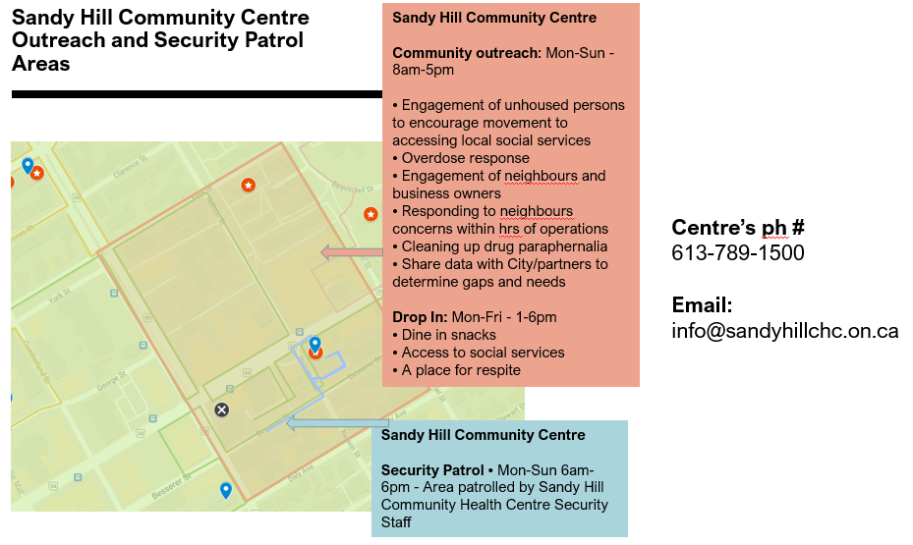

Below is a snapshot of the larger interactive link of community resources map that have mobilized in Sandy Hill for the summer months: SHCHC service area partner resources - Google My Maps

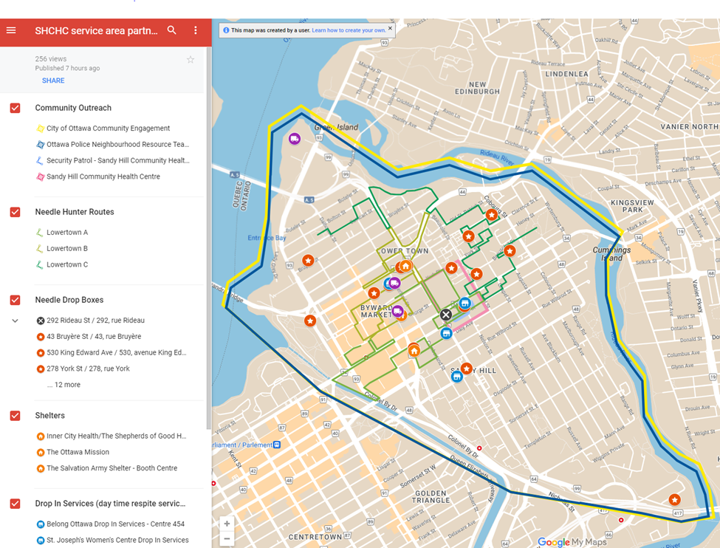

1. **Follow up from community consultations and activities to date re: the upcoming formation of a Community Liaison Group**

Following the 3 community consultation meetings in Sandy Hill between Feb-April 2023, the Centre and City of Ottawa followed up with a communication on June 2, 2023, to those persons (housed, unhoused occupants, business owners and service providers) who participated in the sessions with the intent of informing them of the immediate outcome of those meetings as well as the upcoming activities, in particular, the formation of a community liaison committee. To date, we have secured the services of **Community Mediation Ottawa** (*Community Mediation Ottawa - Canadian Institute for Conflict Resolution* (CICR) (cicr-icrc.ca)). Our hope is to bring in facilitators who have experience with supporting ongoing, difficult and sometimes tense discussions who are well-versed in community-building and we think we have found that with CMO. They have agreed to work with us - Action Sandy Hill Community Association (ASH), Sandy Hill CHC and the City of Ottawa - to help us mobilize a group of residents,

including those experiencing homelessness, business owners and service providers in Sandy Hill so that we can develop a draft mission, terms of reference and operational logistics on bringing a community driven committee to life as the voices for innovative solutions to the ongoing concerns in the area.

Our intent is to hold a first meeting in early August 2023, and so with guidance and support from CMO, we will be reaching out to those who indicated interest in participating in further dialogue in the next three weeks to determine level of interest and availability for becoming a member of this SHCLC, (approx. 16-20 members in size) with broad and widespread representation of this community's diversity, or be part of an information network to ensure transparency, information sharing and ongoing trust building.

At the same time, ASH is forming its own Community and Social Services (CSS) Committee. The ASH CSS Committee will have a wide scope that will address the oversaturation of services in neighbourhood while advocating for our diverse community members in the city and looking into innovative solutions to the problems we face.

In closing, these difficult conversations have become the catalyst to inform and develop a collective community response to the localized Mental Health and Substance Use crisis the area is facing. In the spirit of the City’s recent announcement on Transforming Mental Health and Substance Use Crisis Response in Ottawa – this is an opportunity on a small scale to “reclaim our ability to care for one another” and help shape community informed solutions.