# Briefing Sheet

|  |  |
| --- | --- |
| **To:** | **Action Sandy Hill for purpose of upcoming meeting on Aug 28th, 2023** |
| **From:** | **Sandy Hill Community Health Centre (SHCHC), Oasis Program Director, Wendy Stewart, Email:** **wstewart@sandyhillchc.on.ca****; 613-712-0301** |
| **Date:** | **August 19, 2023** |
| **Subject:** | **Document for context setting on the activities in the last few months re: community engagement activities in Sandy Hill Community related to homelessness and toxic drug supply** |

In response to growing unrest in Ottawa’s Sandy Hill Community related to activities associated with homelessness and the toxic drug supply, the SHCHC and City of Ottawa hosted community consultations on:Feb 28th, March 21 and April 25th, 2023. These were open to housed and unhoused occupants – including people who use drugs, business owners, city staff, police, local social service providers, SHCHC staff and local politicians, for the purpose of creating a dialogue to capture people’s concerns and identify possible solutions. The following are recent activities that have come to fruition following these sessions to help drive community led solutions moving forward and identify all parties involved in possible collaborations to address these concerns collectively:

Pls note that these briefings have also been sent to the office of: Office of MP Mona Fortier and MPP Lucille Collard, Ottawa Police, City if Ottawa and the Action Sandy Hill Community Association as it is the intent of the Centre to be fully transparent in it’s activities as it relates to the CTS.

1. **Open Letter to the Community from Sandy Hill Community Health Centre re: our part in the current community activities:**

“June 1, 2023

To our neighbours across the Sandy Hill community

Our team at the Sandy Hill Community Health Centre (SHCHC) would like to thank you for your frank open feedback about very real concerns about your experience as a neighbour – housed and unhoused, residents and business owners in the area. We are also grateful for your efforts in helping bring forward potential solutions to help address our shared concerns in collaborative and inclusive manners. These difficult conversations are the start of where change can occur.

Between February and April, community members from across Sandy Hill participated in a series of facilitated community conversations that helped us hear your concerns and ideas about how to keep our streets safe, our sidewalks clean, and our people healthy. We also heard that we need to do better - as a health service agency and as a community partner.

As a result of these candid conversations, we would like to outline the following commitments to the community.

In the short-term, we are collaborating with members of Action Sandy Hill (ASH) Community Association and the City of Ottawa to convene a working group made up of stakeholders who can contribute ideas, resources, and help expand our collaborative network with a solutions-driven approach. We are

confident this working group can help shape how the local gaps and needs can be addressed and spearhead the work towards all other objectives that may follow.

Through this group, we will monitor the success of our collective efforts, as well as any potential gaps that remain. Our hope is that the working group will leverage data, partnerships, and innovative thinking to help put in place solutions to address these gaps.

SHCHC has identified and implemented measures within current operations to immediately expand respite services in Sandy Hill for those who are displaced. SHCHC drop-in services are now open Mondays to Fridays, 1 PM – 6 PM, at the Centre, to cover the period of highest demand. This timing has been coordinated to compliment other drop-in services who offer respite spaces in the morning.

SHCHC has been able to reallocate resources and we are in the process of expanding outreach services in the surrounding areas to the Centre. That means that this daily service, operating between 8 AM and 6 PM, will be implemented shortly to include engagement of all community members in the area, respond to localized concerns in relation to those directly or indirectly impacted by harm reduction practices, overdose response and community clean up.

We continue to ramp up to pre-pandemic service hours for the Consumption and Treatment Services. In June, this service will be made available on Saturdays and Sundays, from 8 AM to 6 PM. We are confident that this will encourage people to access services within our space as an alternative to street use. We will monitor the impact for service users and neighbours before moving to our eventual model to operate the service as designed, 7-days-a-week from 8 AM to 8 PM (anticipated by September 11th, 2023)

SHCHC is committed to supporting the working group through full engagement and practical resource supports the group desires (including meeting space / virtual meeting platform, clerical support, partner, and funder relationships, etc.).

We will continue to play a leadership role in bringing the service provider community, funders and elected officials together to address operational gaps.

In the medium to long-term, we will work hand-in-hand with the working group, partners and funders to continue to adapt our services to the changing landscape and needs. We will continue to advocate for adequate funding to meet health and social needs, including affordable housing, equitable access to health and social services, and harm reduction. We will monitor new funding, as well as opportunities to address current and emerging issues. We will continue to work with service providers and community partners to plan for safer inhalation services in Ottawa.

We commit to keeping the conversation going, to listen deeply to stakeholders, to expand and create new ways to keep our community safe and healthy for everyone, by finding solutions to our collective concerns. We are all connected by this shared experience and are deeply appreciative of this community’s drive to create a responsive, vibrant, and connected community for all.

Should you have any questions, comments, or feedback for our team, we can be reached at info@sandyhillchc.on.ca or (613) 789-1500.

Thank you and we look forward to hearing from you.

_______________________________

David Gibson

Executive Director

Sandy Hill Community Health Centre”

1. **Coordinated community response**

In addition, this program has gathered the local service partners to coordinate a collaborative response to the current activities, particularly as it relates to the summer months and the anticipated increase in activities outside and around the area. Together, we formed this virtual map, that will be updated as things evolve, which is soon to be available to the public and service partners : SHCHC service area partner resources - Google My Maps . Our Centre’s commitment, in particular is the following area of increased outreach by June 18th, 2023:



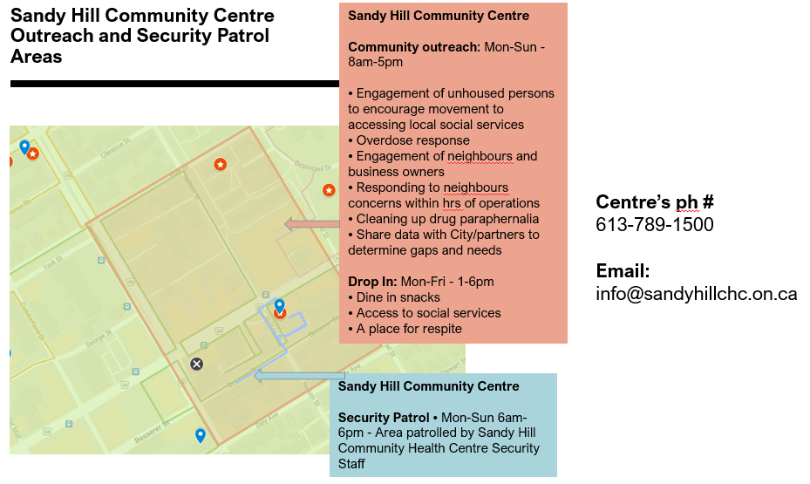

Below is a snapshot of the larger interactive link of community resources map that have mobilized in Sandy Hill for the summer months: SHCHC service area partner resources - Google My Maps

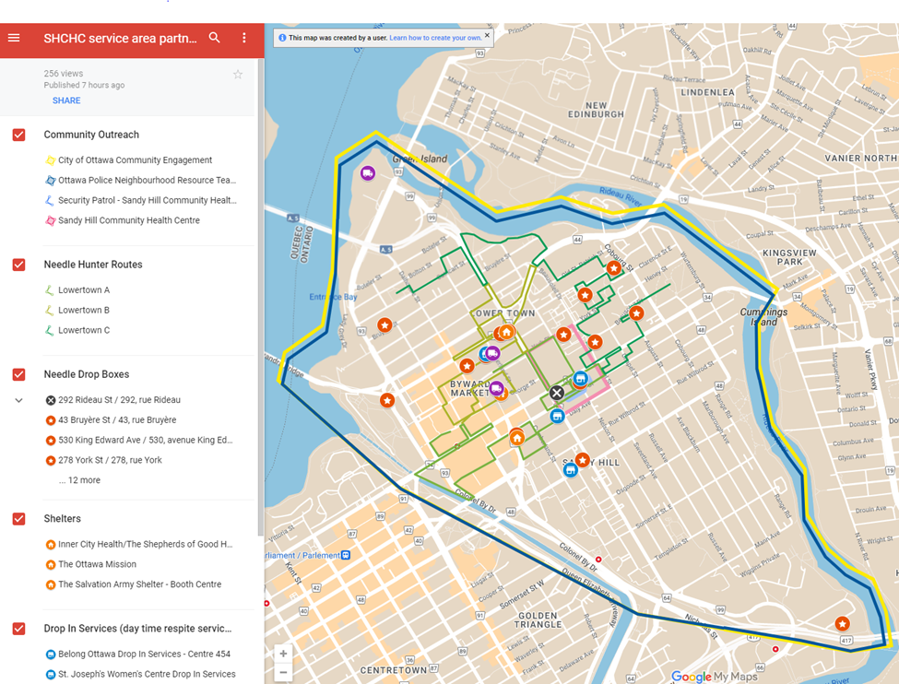

1. **Follow up from community consultations and activities between May-July, 2023 re: the upcoming formation of a Community Liaison Group**

Following the 3 community consultation meetings in Sandy Hill between Feb-April 2023, the Centre and City of Ottawa followed up with a communication on June 2, 2023, to those persons (housed, unhoused occupants, business owners and service providers) who participated in the sessions with the intent of informing them of the immediate outcome of those meetings as well as the upcoming activities, in particular, the formation of a community liaison committee. To date, we have secured the services of **Community Mediation Ottawa** (*Community Mediation Ottawa - Canadian Institute for Conflict Resolution* (CICR) (cicr-icrc.ca)). Our hope is to bring in facilitators who have experience with supporting ongoing, difficult and sometimes tense discussions who are well-versed in community-building and we think we have found that with CMO. They have agreed to work with us - Action Sandy Hill Community Association (ASH), Sandy Hill CHC and the City of Ottawa - to help us mobilize a group of residents,

including those experiencing homelessness, business owners and service providers in Sandy Hill so that we can develop a draft mission, terms of reference and operational logistics on bringing a community driven committee to life as the voices for innovative solutions to the ongoing concerns in the area.

Our intent is to hold a first meeting in early August 2023, and so with guidance and support from CMO, we will be reaching out to those who indicated interest in participating in further dialogue in the next three weeks to determine level of interest and availability for becoming a member of this SHCLC, (approx. 16-20 members in size) with broad and widespread representation of this community's diversity, or be part of an information network to ensure transparency, information sharing and ongoing trust building.

**Below is the Communication we to all participants who participated in the aforementioned community consultations that was sent on June 2, 2023:**

”Good morning all,

We would like to thank you for your participation in the Sandy Hill Conversations, which took place over the course of the last few months. We are grateful for your candour in communicating your concerns and dedication to the health of the community and bringing forward potential solutions to help resolve and address concerns in collaborative and inclusive manners. Although the conversations and processes were difficult we learned a lot through this exercise. Thank you for that.

After the first two meetings, the facilitators identified some themes, however, in the third meeting, we learned some were contentious and we cannot simply move forward with implementation, nor do we want to without your input, participation and leadership. What changes we have been able to implement are included in the appendix below.

So, at the close of this initial series, participants were asked to complete a Call-in-Application that surveyed participants desire to participate in further discussions, as well as what they might be interested in taking on in terms of (re)building the community. Of the participants that attended the final evening (60+) 26 Call-in-Applications were completed.

In moving forward, we have connected with Wendy Stewart, Director of the Sandy Hill Community Health Centre (SHCHC), Oasis Program, and Calla Barnett, Vice-Chair of Action Sandy Hill (ASH) as well as leading ASH’s Social Services Committee. Collectively, we are very interested in continuing the conversation, and in working with all residents of Sandy Hill to search for, and find, solutions to our shared concerns as they relate to the impacts of the toxic drug supply and related behaviors on the community members in the surrounding area.

In this process moving forward, ASH, City of Ottawa and SCHCH have committed to supporting this group through full engagement with the community as well as between these partners providing practical resource supports such as: meeting space (in person and virtual), clerical support, partner and funder relations, etc.). We are in the process of exploring facilitators with mediation competencies so that we can outline the objectives of this working group (terminology to be defined in session) as well as determine the support required.

There will be a follow-up email sent within the next week advising people of the next steps. For now, below this main text, we want to let you know about a few changes that have been implemented by SHCHC and some ASH news regarding Community and Social Services from Calla. If you have questions, please reach out to any of us and we will attempt to answer those questions the best we can.

**Kent Hugh, City of Ottawa, Community Engagement Team (CET)**: kent.hugh@ottawa.ca

**Gerald Dragon, Team Lead, Community Development and Engagement:** gdragon@sandyhillchc.on.ca

**Wendy Stewart, Sandy Hill Community Health Centre, Oasis Program**: wstewart@sandyhillchc.on.ca

**Calla Barnett, Vice-Chair, Action Sandy Hill (ASH) Community Association**: callabarnettash@gmail.com

Sincerely,

Gerald Dragon

Team Lead: Community Development and Engagement/ Chef d'équipe: Développement et engagement communautaire

Sandy Hill Community Health Centre/Centre de Sante Communautaire Cote-de-Sable

Tel:613-690-8631

and

Kent Hugh

Coordinator, CommunityEngagement Team | Coordinateur,équipe d'engagement communautaire

Community and Social Services | Services sociauxet communautaires

Cityof Ottawa | Ville d’Ottawa

Tel: 613-266-9414

New and Upcoming Changes at OASIS:

• SHCHC has found immediate ways to expand respite services in Sandy Hill for those who are displaced. SHCHC drop in services are now open Mondays to Fridays, 1-6pm at the Centre to cover the period of highest demand. We have coordinated this schedule with other drop ins who offer respite spaces in morning.

• SHCHC has been able to reallocate resources and is in the process of operationalizing outreach services in the surrounding areas of the Centre. Operating daily between 8am-6pm, this service will be implemented shortly to include engagement of all community members in the area, respond to localized concerns in relation to those directly or indirectly impacted by harm reduction practices, overdose response and community clean up;

• SHCHC has reached out to local service partners to collaborate on an integrated approach to coordinating resources and providing information to the community to make it easier to know what services are available, what they do and how they can be reached. Please see the following link: SHCHC service area partner resources - Google My Maps

• We continue to ramp up to pre-pandemic service hours for the Consumption and Treatment Site. In June we plan to re-open the service on Saturdays and Sundays from 8am to 6pm. We are confident that this will encourage people to access service within our space as an alternative to street

use. We will monitor the impact for service users and neighbours before moving to our eventual model to operate the service as designed 7 days a week from 8 am to 8 pm

• SHCHC is committed to supporting the working group through full engagement and practical resource supports the group desires (including meeting space / virtual meeting platform, clerical support, partner and funder relationships, etc)

• We will have the capacity for drug testing to help identify the toxic substances, notify the community to prevent further harm and work with providers to be prepared for the impacts of those toxins.

New ASH Community and Social Services (CSS) Committee:

Calla Barnett was new to ASH this year and took over the lead on Community and Social Services file at ASH in January. She will be proposing Terms of Reference to create an official ASH committee. Once those are approved, the ASH CSS Committee will have a wide scope that will address the oversaturation of services in neighbourhood while advocating for our diverse community members in the city and looking into innovative solutions to the problems we face.”

1. **Follow up from community consultations and activities to date re: the upcoming formation of a Community Liaison Group**

As of Aug 11, 2023, we have spoken with over 50 people representing 5 different stakeholder groups in Sandy Hill and have worked diligently to ensure that there is fair outreach across the community in all our efforts. We discussed 3 different ways to be involved and asked you to let us know which of these options would work best for individuals: as a member of the ***Sandy Hill Community Liaison Committee (SHCLC),*** as part of the Communications Network (CN), or a member of the Volunteer Force (VF).

As we coordinated the creation of this *Community Liaison Committee (CLC)*, our ultimate purpose has been to ensure broad and inclusive representation from business owners, service providers, housed residents, residents experiencing homelessness and/or addictions, and others who do not fall into the stated categories (i.e., Library). We engaged Community Mediation Ottawa, part of Canadian Institute for Conflict Resolution, to guide us in this process to ensure that we found a way to be as inclusive and representative as possible. At their recommendation, the CLC will have approximately 25 members: big enough to ensure the equitable representation of the different groups mentioned above, but also well positioned to be operative, nimble and efficient.

As for the *Communication Network (CN)*, we will all be automatic members, and others who have or will come forward as interested parties will be included. The *Communication Network* will serve as an even greater opportunity to gather community ideas, preferences, and guidance and to ensure even broader awareness and support. The *Volunteer Force*will be key to bringing to life the ideas of the *CLC* and engaging the wider Sandy Hill community in events and outreach activities.

Community Mediation Ottawa (*Community Mediation Ottawa - Canadian Institute for Conflict Resolution* (CICR) (cicr-icrc.ca)) will continue working with the *Community Liaison Committee* to facilitate our first meetings and guide us through developing the formal structure. More specifically, we will get to work with Lorna Lemay, who is an expert in the field of launching, developing and establishing effective community committees. She will bring her many years of experience in fostering dialogue, building trust, and giving a voice to all. She will be joined by another Practitioner, Norm Desjardins, who brings his volunteer support and expertise in conflict resolution to the table towards our success.

Over the next week, we will be contacting everyone we have spoken with by email to discuss logistics, including meeting dates and times, confirmed committee representation, an official email list for the *Communications Network,* and other such items. The anticipated initial dates for this committee to meet are: Sept 19, Oct 3 and 17th…. The draft agendas for these meetings can be found on pgs 9,10 & 11 of this brief.

**Pls note the following opportunities for residents beyond what we have offered to express their voice on this matter, they do have an alternative option to participate:**

And, as residents of Sandy Hill, there is a resident-specific committee that has been set up in a more traditional way by Action Sandy Hill. Calla is the Chair of the ASH Community and Social Services Committee. The work will be different from that of the liaison committee. The approved terms of reference are available here: Community and Social Services Terms of Reference – ASH-ACS. If you would like more information about the ASH CSS committee, please contact cssc@ash-acs.ca.

**Sandy Hill Community Liaison Committee (CLC)**

**Agenda**

**Tuesday September 19, 2023; 5:30 to 7:30 p.m.**

**[Library TBC]**

**Meeting Intent:**

* **Introduce CLC concept**
* **Celebrate Sandy Hill Community**
* **Foster Safe Space and Empathic Dialogue**
* **Share Hopes and Expectations**
* **Agree on Logistics**

|  |  |  |
| --- | --- | --- |
| **What?** | **When (mins)?** | **Who?** |
| Welcome & Overview of CLC development | 10 | Facilitators |
| Celebrate Community  Name & 1 sentence about what the community means to you. | 30 | All |
| Introduction to Empathic Dialogue | 15 | Facilitators |
| Safe Space: Setting Group Guidelines | 20 | All |
| PEACE PAUSE | 10 | All |
| Hopes & Expectations  Together, I hope we can _________________.  I need ________________________from the chairs/facilitators, and each other. | 30 | All |
| Logistics:  Next meeting date, place & topics  (Oct 3, Oct 17, & Nov 21) | 5 | Facilitators |
| Closing | 5 |  |

**Sandy Hill Community Liaison Committee (CLC)**

**Agenda**

**Tuesday October 3, 2023; 5:30 to 7:30 p.m.**

**[Library TBC]**

**Meeting Intent:**

* **Foster Trust**
* **Dialogue/consensus on CLC Guiding Documents**
* **Roles & Responsibilities of Committee Members**

|  |  |  |
| --- | --- | --- |
| **What?** | **When (mins)?** | **Who?** |
| Welcome | 10 | Facilitators |
| Review of Guidelines | 10 | Facilitators |
| What defines trust? How do I know when it is present? | 30 | ALL |
| Trust Overview | 10 | Facilitators |
| PEACE PAUSE | 10 | ALL |
| Consensus Decision-making | 10 | Facilitators |
| Review CLC Guiding Documents   * Roles & Responsibilities * Edits/changes * Approval | 30 | ALL |
| Strategic Planning – for Oct 17 meeting | 5 | Facilitators |
| Closing | 5 | Facilitators |

Meeting Dates:

Oct 17, & Nov 21 & every 3rd Tues of month beginning in January

**Sandy Hill Community Liaison Committee (CLC)**

**Agenda**

**Tuesday October 17, 2023; 5:30 to 7:30 p.m.**

**[Library TBC]**

**Meeting Intent:**

* **Foster Trust**
* **Learning on Dignity**
* **Strategic Planning**

|  |  |  |
| --- | --- | --- |
| **What?** | **When (mins)?** | **Who?** |
| Welcome & Guideline Review | 10 | Facilitators |
| What is dignity? Why is it important? | 15 | ALL |
| Strategic Planning   * Confirm/revise Themes   PEACE PAUSE   * Action Planning * Plenary Sharing * Consensus | 20  10  30  15  15 | ALL |
| Closed vote for 2 co-chairs – poll to follow  Closing | 5 | Facilitators |

Meeting Dates:

Nov 21 & every 3rd Tues of month beginning in January

5. In Summary…

Things are starting to improve in the neighbourhood. Our relations with police, the city and the local community association has been very collaborative and here is feedback from a usually disenfranchised neighbour (Board chair of a local condo)….There has been a shift…

